# Summary of Beta Testing Survey Questions

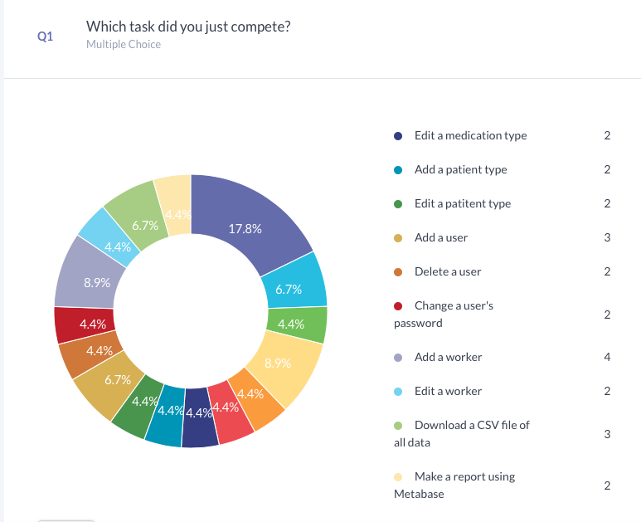

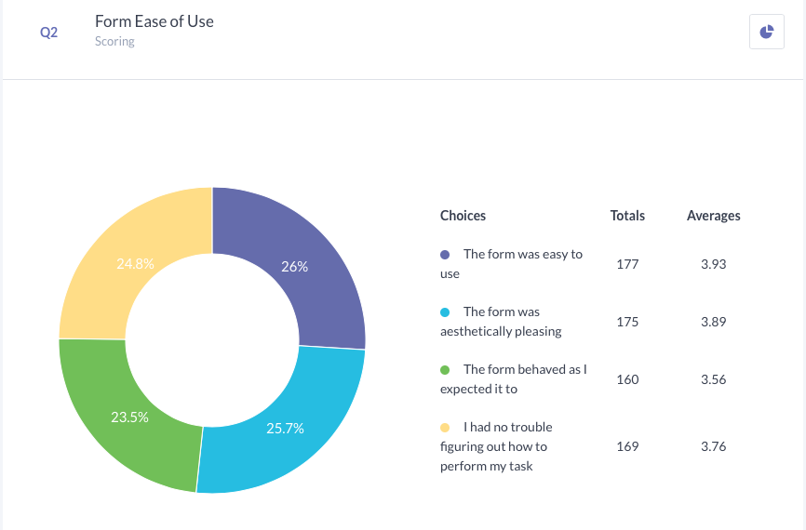

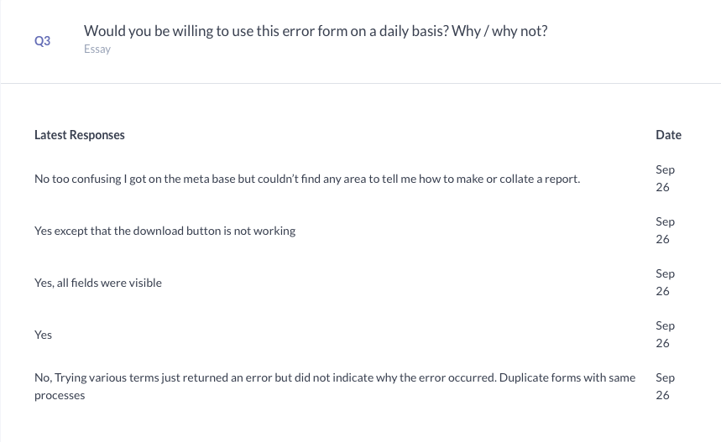

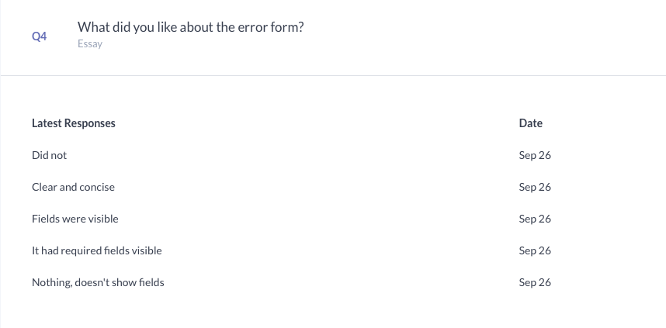

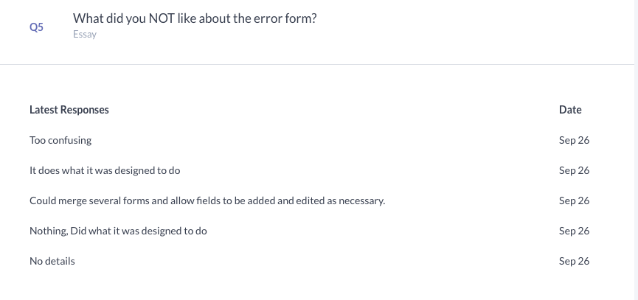

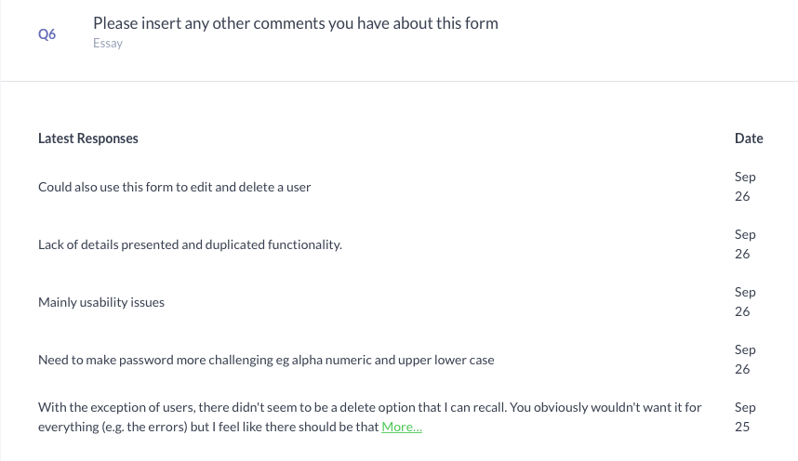

Example of Participant 3’s answers. Full details for each individual participant are following and have been extracted from the survey on <https://www.surveyplanet.com/>

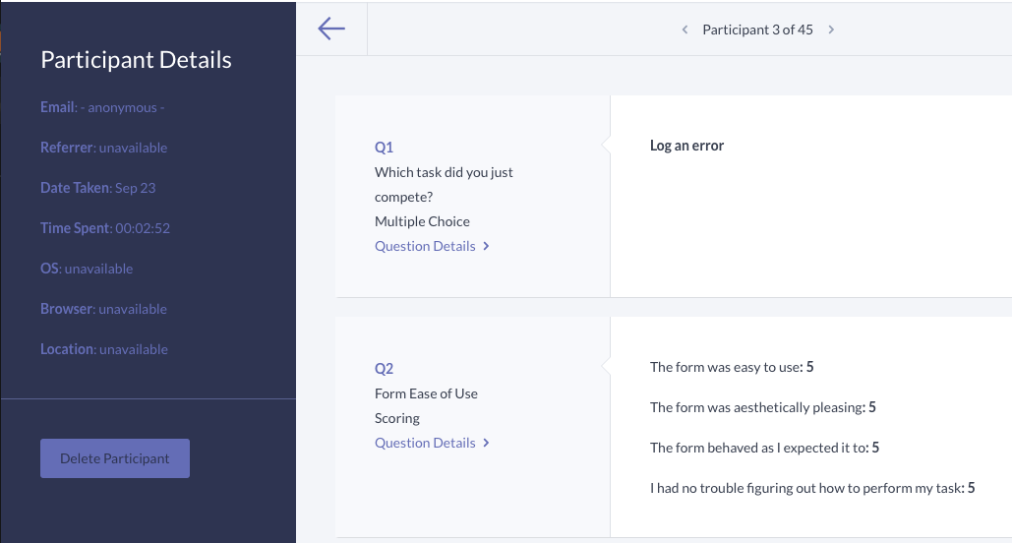

# Participant: 1

*Q1: Which task did you just complete?*

Log an error

*Q2: Form Ease of Use Scoring*

*The form was easy to use:*  3

*The form was aesthetically pleasing:* 3

*The form behaved as I expected it to:* 3

*I had no trouble figuring out how to perform my task:* 3

*Q3: Would you be willing to use this error form on a daily basis? Why / why not?*

Ryan

*Q4: What did you like about the error form?*

Ryan

*Q5: What did you NOT like about the error form?*

Ryan

*Q6: Please insert any other comments you have about this form.*

Ryan

# Participant: 2

*Q1: Which task did you just complete?*

Log an error

*Q2: Form Ease of Use Scoring*

*The form was easy to use:*  5

*The form was aesthetically pleasing:* 4

*The form behaved as I expected it to:* 4

*I had no trouble figuring out how to perform my task:* 4

*Q3: Would you be willing to use this error form on a daily basis? Why / why not?*

Yes

*Q4: What did you like about the error form?*

Everything

*Q5: What did you NOT like about the error form?*

Everything else

*Q6: Please insert any other comments you have about this form.*

# Participant: 3

*Q1: Which task did you just complete?*

Log an error

*Q2: Form Ease of Use Scoring*

*The form was easy to use:*  5

*The form was aesthetically pleasing:* 5

*The form behaved as I expected it to:* 5

*I had no trouble figuring out how to perform my task:* 5

*Q3: Would you be willing to use this error form on a daily basis? Why / why not?*

Yes (if I worked in that field)

*Q4: What did you like about the error form?*

Simple, easy to fill out

*Q5: What did you NOT like about the error form?*

Could possibly use a spot to add any additional information

*Q6: Please insert any other comments you have about this form.*

# Participant: 4

*Q1: Which task did you just complete?*

Log an error

*Q2: Form Ease of Use Scoring*

*The form was easy to use:*  5

*The form was aesthetically pleasing:* 5

*The form behaved as I expected it to:* 5

*I had no trouble figuring out how to perform my task:* 5

*Q3: Would you be willing to use this error form on a daily basis? Why / why not?*

If I was working in a field where this form was relevant, I would definitely be willing to use it on a daily basis.

*Q4: What did you like about the error form?*

It was to the point, with no unnecessary questions or fields to fill in.

*Q5: What did you NOT like about the error form?*

I have zero idea about medicine, so it was interesting to try and fill out.

*Q6: Please insert any other comments you have about this form.*

Perfect for anyone in the relevant field of work to use.

# Participant: 5

*Q1: Which task did you just complete?*

Log an error

*Q2: Form Ease of Use Scoring*

*The form was easy to use:*  4

*The form was aesthetically pleasing:* 4

*The form behaved as I expected it to:* 2

*I had no trouble figuring out how to perform my task:* 4

*Q3: Would you be willing to use this error form on a daily basis? Why / why not?*

I had a problem when entering an error without wanting to put in Physician details. The form came back with an error after I selected submit. It wanted me to enter a Physician Number. I was not able to enter any details. I could only continue by changing to Yes to Physician Details and entering each field. Also, when I went to enter the next error, I didn’t select clear first. I entered all the details but the submit button was not available. I had to select clear and start all over again. This was slightly annoying.

*Q4: What did you like about the error form?*

Ease of use.

*Q5: What did you NOT like about the error form?*

Having to remember to select clear to begin a new entry.

*Q6: Please insert any other comments you have about this form.*

With the exception of the clear issue the application was clean and user friendly.

# Participant: 6

*Q1: Which task did you just complete?*

Edit an error

*Q2: Form Ease of Use Scoring*

*The form was easy to use:*  5

*The form was aesthetically pleasing:* 5

*The form behaved as I expected it to:* 5

*I had no trouble figuring out how to perform my task:* 5

*Q3: Would you be willing to use this error form on a daily basis? Why / why not?*

Yes, easy to use

*Q4: What did you like about the error form?*

Easy to use, straight forward

*Q5: What did you NOT like about the error form?*

If you accidentally hit clear there is no way to undo it, & there was no way to undo your changes

*Q6: Please insert any other comments you have about this form.*

# Participant: 7

*Q1: Which task did you just complete?*

Edit the error form

*Q2: Form Ease of Use Scoring*

*The form was easy to use:*  5

*The form was aesthetically pleasing:* 5

*The form behaved as I expected it to:* 5

*I had no trouble figuring out how to perform my task:* 5

*Q3: Would you be willing to use this error form on a daily basis? Why / why not?*

Yes, easy to use

*Q4: What did you like about the error form?*

Easy to use, straight forward

*Q5: What did you NOT like about the error form?*

.

*Q6: Please insert any other comments you have about this form.*

# Participant: 8

*Q1: Which task did you just complete?*

Add an error type

*Q2: Form Ease of Use Scoring*

*The form was easy to use:*  5

*The form was aesthetically pleasing:* 5

*The form behaved as I expected it to:* 5

*I had no trouble figuring out how to perform my task:* 5

*Q3: Would you be willing to use this error form on a daily basis? Why / why not?*

Yes

*Q4: What did you like about the error form?*

Easy to use, very straight forward

*Q5: What did you NOT like about the error form?*

There does not seem to be a way to delete an error type.

*Q6: Please insert any other comments you have about this form.*

# Participant: 9

*Q1: Which task did you just complete?*

Edit an error type

*Q2: Form Ease of Use Scoring*

*The form was easy to use:*  5

*The form was aesthetically pleasing:* 5

*The form behaved as I expected it to:* 5

*I had no trouble figuring out how to perform my task:* 5

*Q3: Would you be willing to use this error form on a daily basis? Why / why not?*

Yes

*Q4: What did you like about the error form?*

Easy to use, straight forward

*Q5: What did you NOT like about the error form?*

There was no way to delete an error type.

*Q6: Please insert any other comments you have about this form.*

.

# Participant: 10

*Q1: Which task did you just complete?*

Add a medication type

*Q2: Form Ease of Use Scoring*

*The form was easy to use:*  3

*The form was aesthetically pleasing:* 5

*The form behaved as I expected it to:* 1

*I had no trouble figuring out how to perform my task:* 1

*Q3: Would you be willing to use this error form on a daily basis? Why / why not?*

Overall yes, for this particular function no

*Q4: What did you like about the error form?*

Easy to get to/find in the drop down menu

*Q5: What did you NOT like about the error form?*

When I tried to add a medication type it kept coming up with a message saying “an error has occurred” so I wasn’t able to add one

*Q6: Please insert any other comments you have about this form.*

# Participant: 11

*Q1: Which task did you just complete?*

Edit a medication type

*Q2: Form Ease of Use Scoring*

*The form was easy to use:*  5

*The form was aesthetically pleasing:* 5

*The form behaved as I expected it to:* 5

*I had no trouble figuring out how to perform my task:* 5

*Q3: Would you be willing to use this error form on a daily basis? Why / why not?*

Yes

*Q4: What did you like about the error form?*

Easy to use

*Q5: What did you NOT like about the error form?*

.

*Q6: Please insert any other comments you have about this form.*

# Participant: 12

*Q1: Which task did you just complete?*

Add a patient type

*Q2: Form Ease of Use Scoring*

*The form was easy to use:*  3

*The form was aesthetically pleasing:* 5

*The form behaved as I expected it to:* 1

*I had no trouble figuring out how to perform my task:* 1

*Q3: Would you be willing to use this error form on a daily basis? Why / why not?*

Overall yes, for this task no

*Q4: What did you like about the error form?*

Easy to get to the section

*Q5: What did you NOT like about the error form?*

Kept coming up with an error message, was not able to add a patient type

*Q6: Please insert any other comments you have about this form.*

# Participant: 13

*Q1: Which task did you just complete?*

Edit a patient type

*Q2: Form Ease of Use Scoring*

*The form was easy to use:*  5

*The form was aesthetically pleasing:* 5

*The form behaved as I expected it to:* 5

*I had no trouble figuring out how to perform my task:* 5

*Q3: Would you be willing to use this error form on a daily basis? Why / why not?*

Yes

*Q4: What did you like about the error form?*

Easy to use

*Q5: What did you NOT like about the error form?*

.

*Q6: Please insert any other comments you have about this form.*

# Participant: 14

*Q1: Which task did you just complete?*

Add a user

*Q2: Form Ease of Use Scoring*

*The form was easy to use:*  5

*The form was aesthetically pleasing:* 5

*The form behaved as I expected it to:* 5

*I had no trouble figuring out how to perform my task:* 5

*Q3: Would you be willing to use this error form on a daily basis? Why / why not?*

Yes

*Q4: What did you like about the error form?*

Easy to use

*Q5: What did you NOT like about the error form?*

.

*Q6: Please insert any other comments you have about this form.*

# Participant: 15

*Q1: Which task did you just complete?*

Delete a user

*Q2: Form Ease of Use Scoring*

*The form was easy to use:*  5

*The form was aesthetically pleasing:* 5

*The form behaved as I expected it to:* 5

*I had no trouble figuring out how to perform my task:* 5

*Q3: Would you be willing to use this error form on a daily basis? Why / why not?*

Yes

*Q4: What did you like about the error form?*

Easy to use

*Q5: What did you NOT like about the error form?*

.

*Q6: Please insert any other comments you have about this form.*

# Participant: 16

*Q1: Which task did you just complete?*

Change a user’s password

*Q2: Form Ease of Use Scoring*

*The form was easy to use:*  5

*The form was aesthetically pleasing:* 5

*The form behaved as I expected it to:* 5

*I had no trouble figuring out how to perform my task:* 5

*Q3: Would you be willing to use this error form on a daily basis? Why / why not?*

Yes

*Q4: What did you like about the error form?*

Easy to use

*Q5: What did you NOT like about the error form?*

.

*Q6: Please insert any other comments you have about this form.*

# Participant: 17

*Q1: Which task did you just complete?*

Add a worker

*Q2: Form Ease of Use Scoring*

*The form was easy to use:*  5

*The form was aesthetically pleasing:* 5

*The form behaved as I expected it to:* 5

*I had no trouble figuring out how to perform my task:* 5

*Q3: Would you be willing to use this error form on a daily basis? Why / why not?*

Yes

*Q4: What did you like about the error form?*

Easy to use

*Q5: What did you NOT like about the error form?*

.

*Q6: Please insert any other comments you have about this form.*

# Participant: 18

*Q1: Which task did you just complete?*

Edit a worker

*Q2: Form Ease of Use Scoring*

*The form was easy to use:*  5

*The form was aesthetically pleasing:* 5

*The form behaved as I expected it to:* 5

*I had no trouble figuring out how to perform my task:* 5

*Q3: Would you be willing to use this error form on a daily basis? Why / why not?*

Yes

*Q4: What did you like about the error form?*

Easy to use

*Q5: What did you NOT like about the error form?*

.

*Q6: Please insert any other comments you have about this form.*

# Participant: 19

*Q1: Which task did you just complete?*

Download a CSV file of all data

*Q2: Form Ease of Use Scoring*

*The form was easy to use:*  5

*The form was aesthetically pleasing:* 5

*The form behaved as I expected it to:* 5

*I had no trouble figuring out how to perform my task:* 5

*Q3: Would you be willing to use this error form on a daily basis? Why / why not?*

Yes

*Q4: What did you like about the error form?*

Easy to use

*Q5: What did you NOT like about the error form?*

.

*Q6: Please insert any other comments you have about this form.*

# Participant: 20

*Q1: Which task did you just complete?*

Making a report using Metabase

*Q2: Form Ease of Use Scoring*

*The form was easy to use:*  3

*The form was aesthetically pleasing:* 3

*The form behaved as I expected it to:* 1

*I had no trouble figuring out how to perform my task:* 1

*Q3: Would you be willing to use this error form on a daily basis? Why / why not?*

In general yes, this part no

*Q4: What did you like about the error form?*

.

*Q5: What did you NOT like about the error form?*

When I clicked on reporting, the web browser said it couldn’t connect to the server, so wasn’t able to open it.

*Q6: Please insert any other comments you have about this form.*

# Participant: 21

*Q1: Which task did you just complete?*

Add a worker

*Q2: Form Ease of Use Scoring*

*The form was easy to use:*  5

*The form was aesthetically pleasing:* 5

*The form behaved as I expected it to:* 5

*I had no trouble figuring out how to perform my task:* 5

*Q3: Would you be willing to use this error form on a daily basis? Why / why not?*

Yes

*Q4: What did you like about the error form?*

Easy to use

*Q5: What did you NOT like about the error form?*

I found that it was misleading that all the manage sections were called manage when all you can do is add a new worker/user etc. If you actually wanted to manage (edit/delete etc) them you had to go to the search function

*Q6: Please insert any other comments you have about this form.*

With exception of users, there didn’t seem to be a delete option that I can recall. You obviously wouldn’t want it for everything (e.g. the errors) but I feel like there should be that option for some of the other sections (e.g. workers, if somebody leaves to work somewhere else, do they still need to be in the system?)

# Participant: 22

*Q1: Which task did you just complete?*

Log an error

*Q2: Form Ease of Use Scoring*

*The form was easy to use:*  3

*The form was aesthetically pleasing:* 3

*The form behaved as I expected it to:* 4

*I had no trouble figuring out how to perform my task:* 5

*Q3: Would you be willing to use this error form on a daily basis? Why / why not?*

Yes though need more limiting of field sizes line in patient number to limit error input

*Q4: What did you like about the error form?*

Relative ease of use

*Q5: What did you NOT like about the error form?*

No limitation on number so could be put wrong

*Q6: Please insert any other comments you have about this form.*

# Participant: 23

*Q1: Which task did you just complete?*

Edit an error

*Q2: Form Ease of Use Scoring*

*The form was easy to use:*  1

*The form was aesthetically pleasing:* 3

*The form behaved as I expected it to:* 1

*I had no trouble figuring out how to perform my task:* 1

*Q3: Would you be willing to use this error form on a daily basis? Why / why not?*

I tried three times to edit an error and it expected me to edit details I didn’t have like patient number when I only wanted to put in more details on the error itself

*Q4: What did you like about the error form?*

Didn’t complete

*Q5: What did you NOT like about the error form?*

As previously stated

*Q6: Please insert any other comments you have about this form.*

# Participant: 24

*Q1: Which task did you just complete?*

Edit the error form

*Q2: Form Ease of Use Scoring*

*The form was easy to use:*  5

*The form was aesthetically pleasing:* 5

*The form behaved as I expected it to:* 5

*I had no trouble figuring out how to perform my task:* 5

*Q3: Would you be willing to use this error form on a daily basis? Why / why not?*

To amend the form yes

*Q4: What did you like about the error form?*

Easy one tick removal

*Q5: What did you NOT like about the error form?*

Noth8ng

*Q6: Please insert any other comments you have about this form.*

# Participant: 25

*Q1: Which task did you just complete?*

Add an error type

*Q2: Form Ease of Use Scoring*

*The form was easy to use:*  5

*The form was aesthetically pleasing:* 5

*The form behaved as I expected it to:* 5

*I had no trouble figuring out how to perform my task:* 5

*Q3: Would you be willing to use this error form on a daily basis? Why / why not?*

Yes

*Q4: What did you like about the error form?*

Easy to add

*Q5: What did you NOT like about the error form?*

Nothing

*Q6: Please insert any other comments you have about this form.*

# Participant: 26

*Q1: Which task did you just complete?*

Edit an error type

*Q2: Form Ease of Use Scoring*

*The form was easy to use:*  5

*The form was aesthetically pleasing:* 2

*The form behaved as I expected it to:* 5

*I had no trouble figuring out how to perform my task:* 5

*Q3: Would you be willing to use this error form on a daily basis? Why / why not?*

No would be afraid of entering the wrong details or changing the form wrongly. Must limit ability to change form

*Q4: What did you like about the error form?*

To easy to use and change things wrong

*Q5: What did you NOT like about the error form?*

As state previously too easy to change

*Q6: Please insert any other comments you have about this form.*

# Participant: 27

*Q1: Which task did you just complete?*

Add a medication type

*Q2: Form Ease of Use Scoring*

*The form was easy to use:*  1

*The form was aesthetically pleasing:* 1

*The form behaved as I expected it to:* 1

*I had no trouble figuring out how to perform my task:* 1

*Q3: Would you be willing to use this error form on a daily basis? Why / why not?*

Wouldn’t let me add an medication type

*Q4: What did you like about the error form?*

Couldn’t use for adding a medication type

*Q5: What did you NOT like about the error form?*

As stated before couldn’t do

*Q6: Please insert any other comments you have about this form.*

# Participant: 28

*Q1: Which task did you just complete?*

Edit a medication type

*Q2: Form Ease of Use Scoring*

*The form was easy to use:*  5

*The form was aesthetically pleasing:* 3

*The form behaved as I expected it to:* 5

*I had no trouble figuring out how to perform my task:* 5

*Q3: Would you be willing to use this error form on a daily basis? Why / why not?*

No can’t edit but not add medication

*Q4: What did you like about the error form?*

Easy to edit

*Q5: What did you NOT like about the error form?*

Nothing

*Q6: Please insert any other comments you have about this form.*

# Participant: 29

*Q1: Which task did you just complete?*

Add a patient type

*Q2: Form Ease of Use Scoring*

*The form was easy to use:*  1

*The form was aesthetically pleasing:* 1

*The form behaved as I expected it to:* 1

*I had no trouble figuring out how to perform my task:* 1

*Q3: Would you be willing to use this error form on a daily basis? Why / why not?*

Wouldn’t let me add a patient type

*Q4: What did you like about the error form?*

Easy to find the field to amend it but not working

*Q5: What did you NOT like about the error form?*

Wasn’t working

*Q6: Please insert any other comments you have about this form.*

# Participant: 30

*Q1: Which task did you just complete?*

Edit a patient type

*Q2: Form Ease of Use Scoring*

*The form was easy to use:*  5

*The form was aesthetically pleasing:* 5

*The form behaved as I expected it to:* 5

*I had no trouble figuring out how to perform my task:* 5

*Q3: Would you be willing to use this error form on a daily basis? Why / why not?*

Yes

*Q4: What did you like about the error form?*

Easy to edit

*Q5: What did you NOT like about the error form?*

Can’t add but can edit

*Q6: Please insert any other comments you have about this form.*

# Participant: 31

*Q1: Which task did you just complete?*

Add a user

*Q2: Form Ease of Use Scoring*

*The form was easy to use:*  5

*The form was aesthetically pleasing:* 5

*The form behaved as I expected it to:* 5

*I had no trouble figuring out how to perform my task:* 5

*Q3: Would you be willing to use this error form on a daily basis? Why / why not?*

Yes

*Q4: What did you like about the error form?*

Easy to add user

*Q5: What did you NOT like about the error form?*

Nothing

*Q6: Please insert any other comments you have about this form.*

Need to make password more challenging eg alpha numeric and upper lower case

# Participant: 32

*Q1: Which task did you just complete?*

Delete a user

*Q2: Form Ease of Use Scoring*

*The form was easy to use:*  5

*The form was aesthetically pleasing:* 5

*The form behaved as I expected it to:* 5

*I had no trouble figuring out how to perform my task:* 5

*Q3: Would you be willing to use this error form on a daily basis? Why / why not?*

Yes

*Q4: What did you like about the error form?*

Easy to use

*Q5: What did you NOT like about the error form?*

Nothing

*Q6: Please insert any other comments you have about this form.*

# Participant: 33

*Q1: Which task did you just complete?*

Change a user’s password

*Q2: Form Ease of Use Scoring*

*The form was easy to use:*  5

*The form was aesthetically pleasing:* 5

*The form behaved as I expected it to:* 5

*I had no trouble figuring out how to perform my task:* 5

*Q3: Would you be willing to use this error form on a daily basis? Why / why not?*

Yes

*Q4: What did you like about the error form?*

Ease of use maybe a bit too easy

*Q5: What did you NOT like about the error form?*

Nothing

*Q6: Please insert any other comments you have about this form.*

# Participant: 34

*Q1: Which task did you just complete?*

Add a worker

*Q2: Form Ease of Use Scoring*

*The form was easy to use:*  1

*The form was aesthetically pleasing:* 1

*The form behaved as I expected it to:* 1

*I had no trouble figuring out how to perform my task:* 1

*Q3: Would you be willing to use this error form on a daily basis? Why / why not?*

Isn’t working

*Q4: What did you like about the error form?*

Not working

*Q5: What did you NOT like about the error form?*

It won’t let me add a worker

*Q6: Please insert any other comments you have about this form.*

# Participant: 35

*Q1: Which task did you just complete?*

Edit a worker

*Q2: Form Ease of Use Scoring*

*The form was easy to use:*  5

*The form was aesthetically pleasing:* 5

*The form behaved as I expected it to:* 5

*I had no trouble figuring out how to perform my task:* 5

*Q3: Would you be willing to use this error form on a daily basis? Why / why not?*

Yes

*Q4: What did you like about the error form?*

Ease of editing

*Q5: What did you NOT like about the error form?*

Can’t add but can edit (emoji)

*Q6: Please insert any other comments you have about this form.*

# Participant: 36

*Q1: Which task did you just complete?*

Log an error

*Q2: Form Ease of Use Scoring*

*The form was easy to use:*  3

*The form was aesthetically pleasing:* 3

*The form behaved as I expected it to:* 1

*I had no trouble figuring out how to perform my task:* 1

*Q3: Would you be willing to use this error form on a daily basis? Why / why not?*

No, there are no patient details retrieved so can’t enter error details. Edits are then applied for missing fields and form can’t be saved.

*Q4: What did you like about the error form?*

Laid out logically

*Q5: What did you NOT like about the error form?*

Not prefilling patient details when populating form

*Q6: Please insert any other comments you have about this form.*

# Participant: 37

*Q1: Which task did you just complete?*

Download a CSV file of all data

*Q2: Form Ease of Use Scoring*

*The form was easy to use:*  5

*The form was aesthetically pleasing:* 3

*The form behaved as I expected it to:* 1

*I had no trouble figuring out how to perform my task:* 5

*Q3: Would you be willing to use this error form on a daily basis? Why / why not?*

Wouldn’t let me download or open the created csv file

*Q4: What did you like about the error form?*

Not work8ng

*Q5: What did you NOT like about the error form?*

Not working

*Q6: Please insert any other comments you have about this form.*

# Participant: 38

*Q1: Which task did you just complete?*

Add an error type

*Q2: Form Ease of Use Scoring*

*The form was easy to use:*  1

*The form was aesthetically pleasing:* 1

*The form behaved as I expected it to:* 1

*I had no trouble figuring out how to perform my task:* 1

*Q3: Would you be willing to use this error form on a daily basis? Why / why not?*

No

*Q4: What did you like about the error form?*

It won’t let me add a patientor errorctype etc from the drop down box but it will from admin home maybe make it one or the other

*Q5: What did you NOT like about the error form?*

See previous answer

*Q6: Please insert any other comments you have about this form.*

# Participant: 39

*Q1: Which task did you just complete?*

Log an error

*Q2: Form Ease of Use Scoring*

*The form was easy to use:*  5

*The form was aesthetically pleasing:* 5

*The form behaved as I expected it to:* 5

*I had no trouble figuring out how to perform my task:* 5

*Q3: Would you be willing to use this error form on a daily basis? Why / why not?*

Yes

*Q4: What did you like about the error form?*

Ease of use

*Q5: What did you NOT like about the error form?*

Doesn’t need both admin home links and drop down links is double dipping and may confuse some users

*Q6: Please insert any other comments you have about this form.*

# Participant: 40

*Q1: Which task did you just complete?*

Edit an error

*Q2: Form Ease of Use Scoring*

*The form was easy to use:*  2

*The form was aesthetically pleasing:* 2

*The form behaved as I expected it to:* 2

*I had no trouble figuring out how to perform my task:* 2

*Q3: Would you be willing to use this error form on a daily basis? Why / why not?*

No. No patient details returned. Also choosing physician details Yes then choosing No still has the error on form message

*Q4: What did you like about the error form?*

It was compact but I would prefer the form has patient details displayed then can use show fields to brin up other fields

*Q5: What did you NOT like about the error form?*

Hides all fields

*Q6: Please insert any other comments you have about this form.*

# Participant: 41

*Q1: Which task did you just complete?*

Add an error type

*Q2: Form Ease of Use Scoring*

*The form was easy to use:*  3

*The form was aesthetically pleasing:* 3

*The form behaved as I expected it to:* 2

*I had no trouble figuring out how to perform my task:* 2

*Q3: Would you be willing to use this error form on a daily basis? Why / why not?*

No, Trying various terms just returned an error but did not indicate why the error occurred. Duplicate forms with the same process

*Q4: What did you like about the error form?*

Nothing, doesn’t show fields

*Q5: What did you NOT like about the error form?*

No details

*Q6: Please insert any other comments you have about this form.*

# Participant: 42

*Q1: Which task did you just complete?*

Add a user

*Q2: Form Ease of Use Scoring*

*The form was easy to use:*  3

*The form was aesthetically pleasing:* 3

*The form behaved as I expected it to:* 3

*I had no trouble figuring out how to perform my task:* 3

*Q3: Would you be willing to use this error form on a daily basis? Why / why not?*

Yes

*Q4: What did you like about the error form?*

It had required fields visible

*Q5: What did you NOT like about the error form?*

Nothing, Did what it was designed to do

*Q6: Please insert any other comments you have about this form.*

Could also use this form to edit and delete a user

# Participant: 43

*Q1: Which task did you just complete?*

Add a worker

*Q2: Form Ease of Use Scoring*

*The form was easy to use:*  3

*The form was aesthetically pleasing:* 3

*The form behaved as I expected it to:* 3

*I had no trouble figuring out how to perform my task:* 3

*Q3: Would you be willing to use this error form on a daily basis? Why / why not?*

Yes, all fields were visible

*Q4: What did you like about the error form?*

Fields were visible

*Q5: What did you NOT like about the error form?*

Could merge several forms and allow fields to be added and edited as necessary

*Q6: Please insert any other comments you have about this form.*

# Participant: 44

*Q1: Which task did you just complete?*

Download a CSV file of all data

*Q2: Form Ease of Use Scoring*

*The form was easy to use:*  3

*The form was aesthetically pleasing:* 3

*The form behaved as I expected it to:* 1

*I had no trouble figuring out how to perform my task:* 3

*Q3: Would you be willing to use this error form on a daily basis? Why / why not?*

Yes except that the download button is not working

*Q4: What did you like about the error form?*

Clear and concise

*Q5: What did you NOT like about the error form?*

It does what it was designed to do

*Q6: Please insert any other comments you have about this form.*

# Participant: 45

*Q1: Which task did you just complete?*

Making a report using Metabase

*Q2: Form Ease of Use Scoring*

*The form was easy to use:*  1

*The form was aesthetically pleasing:* 1

*The form behaved as I expected it to:* 1

*I had no trouble figuring out how to perform my task:* 1

*Q3: Would you be willing to use this error form on a daily basis? Why / why not?*

No too confusing I got on the meta base but couldn’t find any area to tell me how to make or collate a report

*Q4: What did you like about the error form?*

Did not

*Q5: What did you NOT like about the error form?*

Too confusing

*Q6: Please insert any other comments you have about this form.*